**Knippa FFA**

**Awards Banquet**

**May 11, 2015**

Flag Ceremonies 2015-16 Officers

Invocation Dani Layne

Meal & Chapter Slideshow

Special Musical Performance José Alonzo

Opening Ceremonies Chapter Officers

Recognition of Special Guests Alyssandra Menchaca

Recognition of Banquet Cook Matthew Phillips

Presentation of Honorary Chapter Farmer Dani Layne

Presentation of Forever Blue Award Ryan Tomaselli

Introduction of Retiring Addresses Gabby Menchaca

Retiring Addresses Alyssandra Menchaca

Ryan Tomaselli

Matthew Phillips

Presentation of Top Sellers Wyatt Barrow

Livestock Show Participation Awards Dani Layne

Presentation of Individual Achievements Wyatt Barrow

Presentation of State CDE Winners Ryan Tomaselli

New Officer Election Process Matthew Phillips

Discovery FFA Degree Chapter Officers

Greenhand FFA Degrees/Star Greenhand Chapter Officers

Chapter Degrees Ceremony Chapter Officers

Star Chapter Farmer Degrees Gabby Menchaca

Presentation of Proficiency Awards Alyssandra Menchaca

Senior & Special Recognition Brandon Callis

Presentation of DEKALB Award Brandon Callis

Retiring of 2014-15 Chapter Officers Chapter Officers

Installation of 2015-16 Chapter Officers Chapter Officers

Final Walk of Retiring Officers Retiring Officers

Closing Ceremonies 2015-16 Officers

**Knippa FFA Officer Teams**

2014-2015 Chapter Officers

President Alyssandra Menchaca Vice-President Matthew Phillips

Secretary Dani Layne

Treasurer Ryan Tomaselli Reporter Gabby Menchaca

Sentinel Wyatt Barrow

2014-2015 Revaldina FFA District Secretary *&*

2015–2016 Texas FFA State Officer Candidate

Matthew Phillips

2015-2016 Chapter Officers

Seth Andres __________________

Wyatt Barrow __________________ Gage Brown __________________

Dani Layne __________________

Gabby Menchaca __________________

Brittney Rangel __________________

Advisor Brandon Callis

Superintendent Jeff Cottrill

Transportation Director Lee Alejandro

Business Manager Elda Alejandro

**Special thanks to the provider**

**of this evening’s meal:**

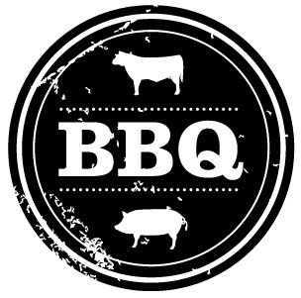

**Todd Phillips**

**Thanks for your support and have a safe trip home!**

**Knippa FFA**

**Annual Awards**

**Banquet**

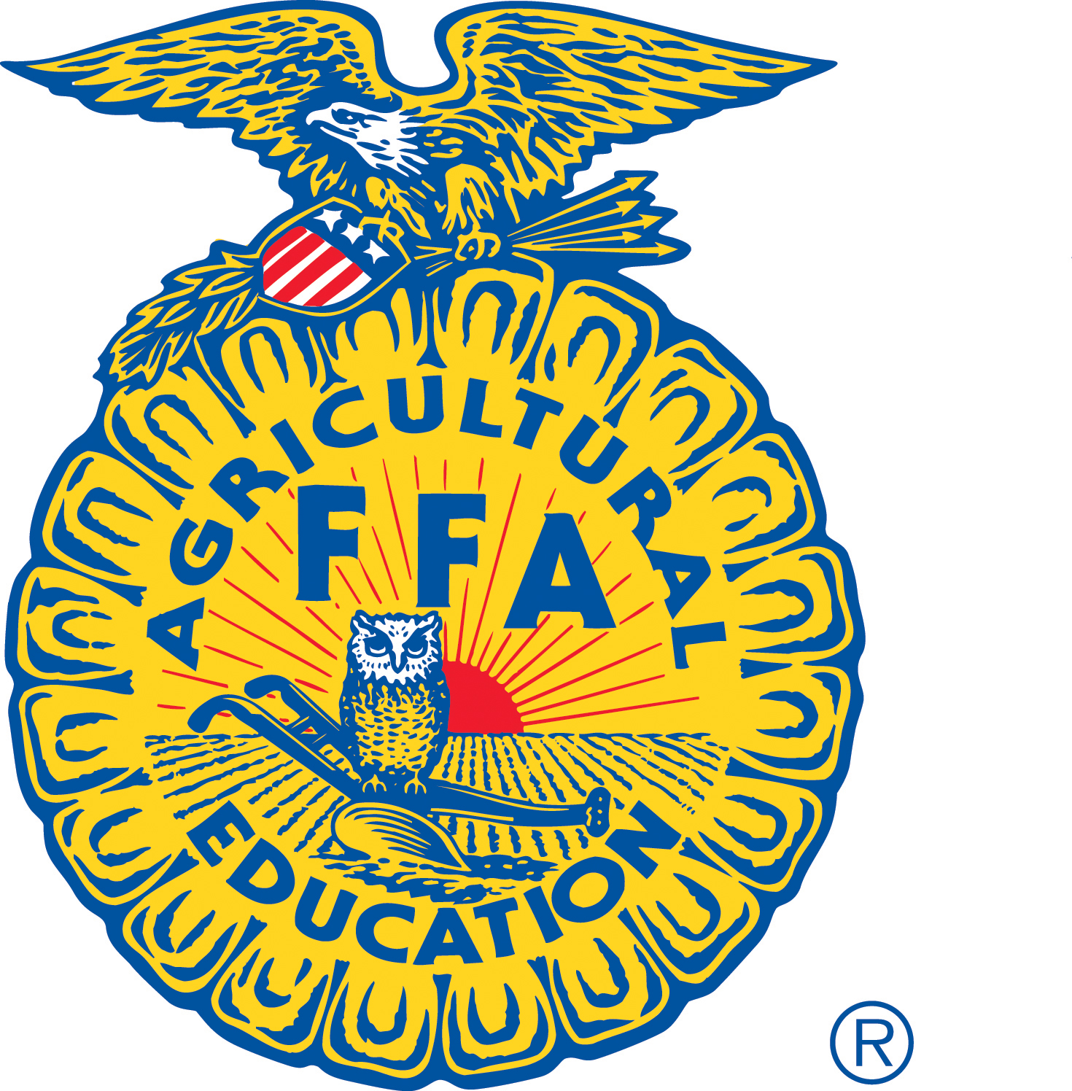

**May 11, 2015**